To participate in the online conference, you must perform the following steps.
Type the following address in a browser (preferably Chrome):
https://tube5.tntu.edu.ua/b/rom-4c4-4ke
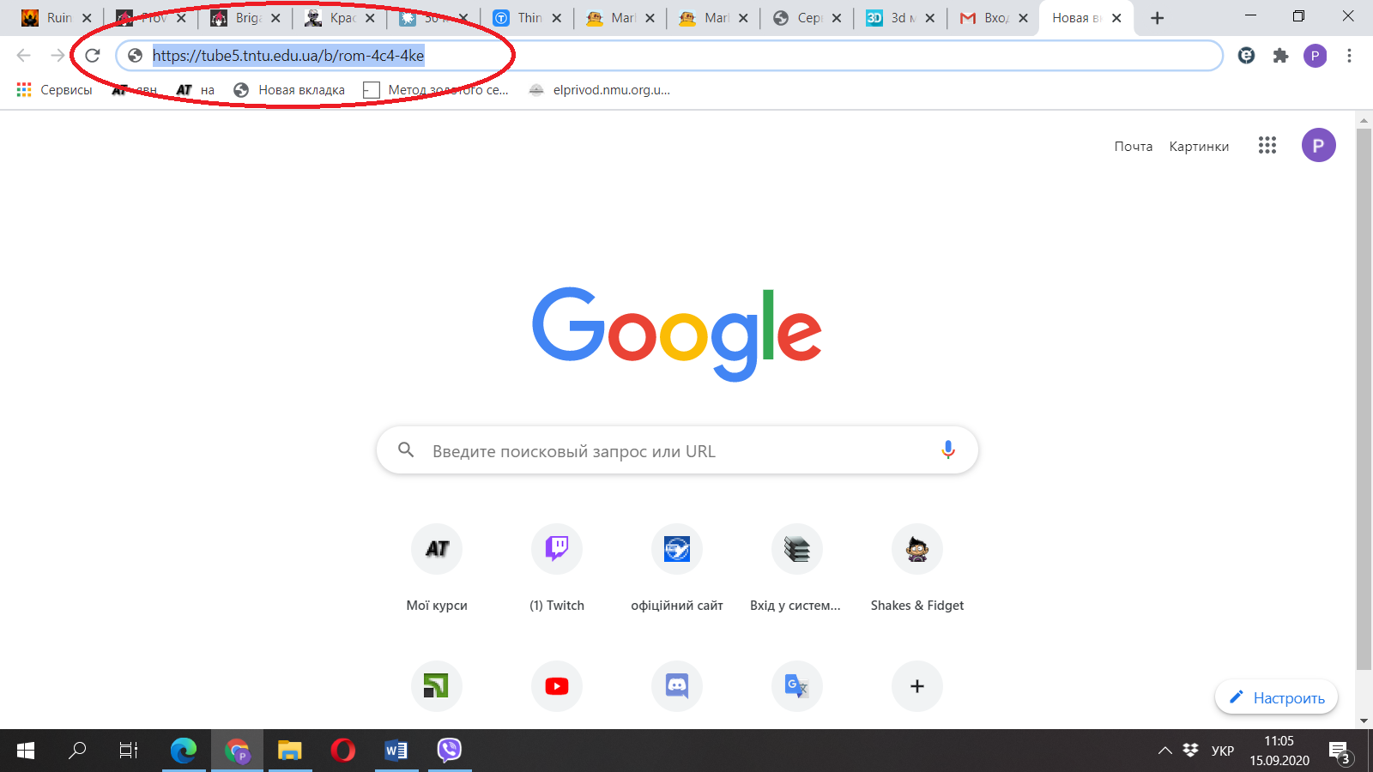

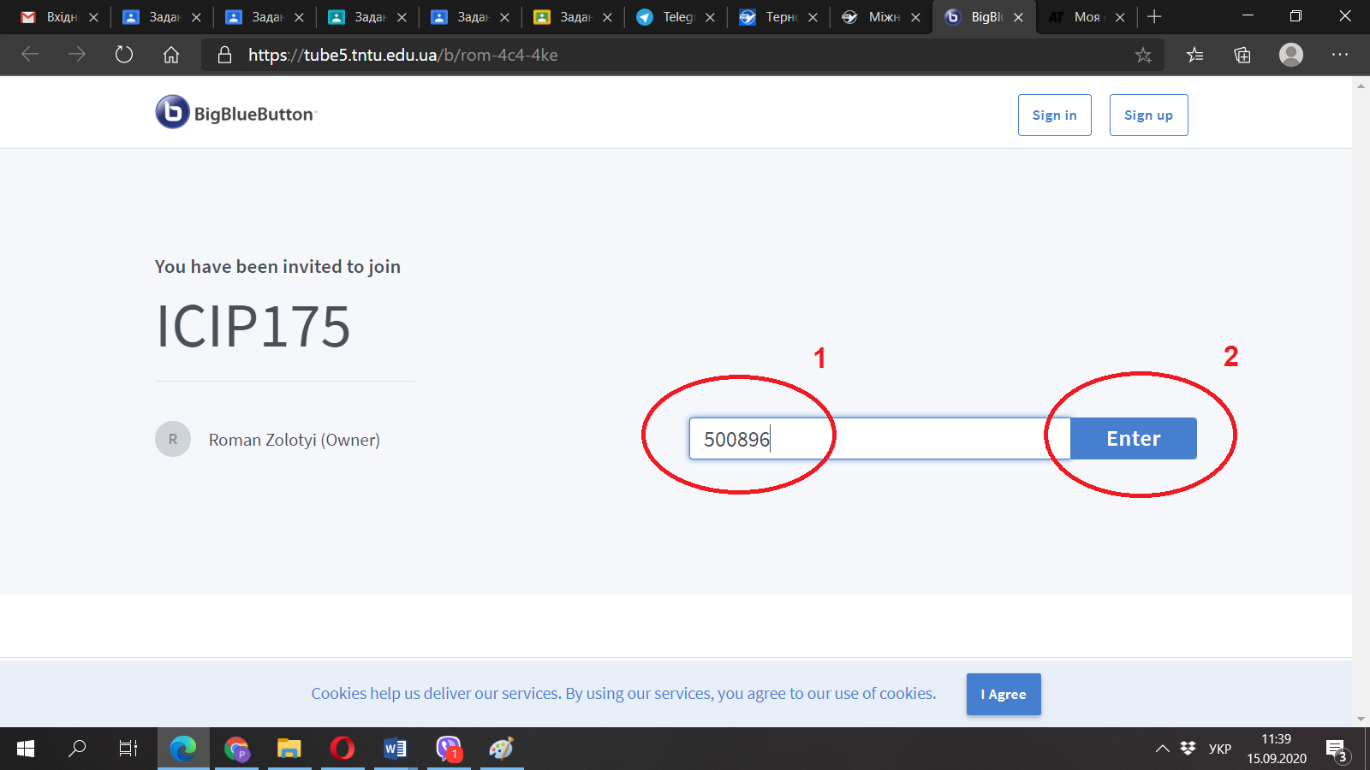

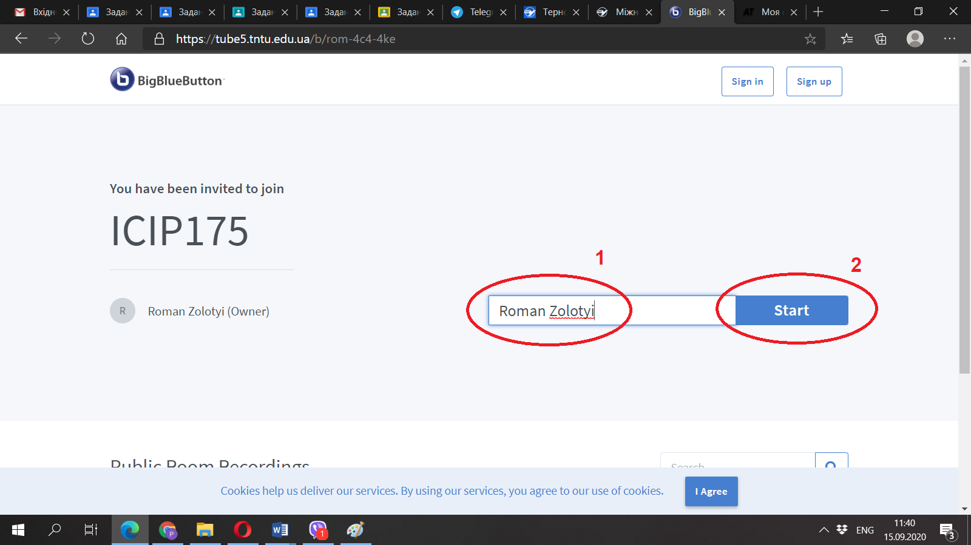
You will then be automatically joined to the meeting or a waiting window will appear if the conference has not yet started.
If the meeting has started, the following window will open:
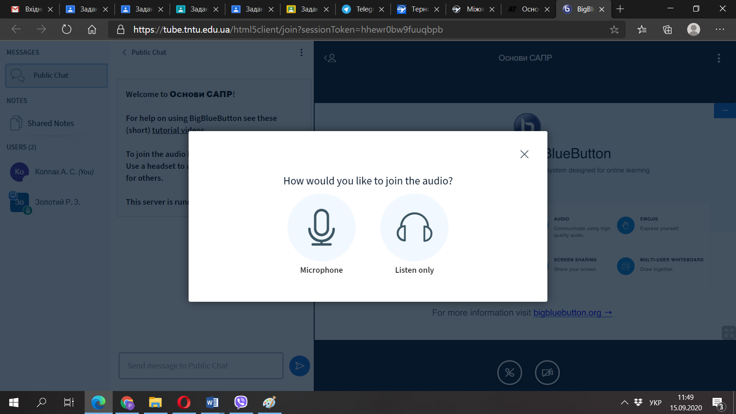
You must select one of two modes. If you want to say something or ask a question - you need to choose a microphone. Next, check if you hear yourself and click the icon labeled Yes.
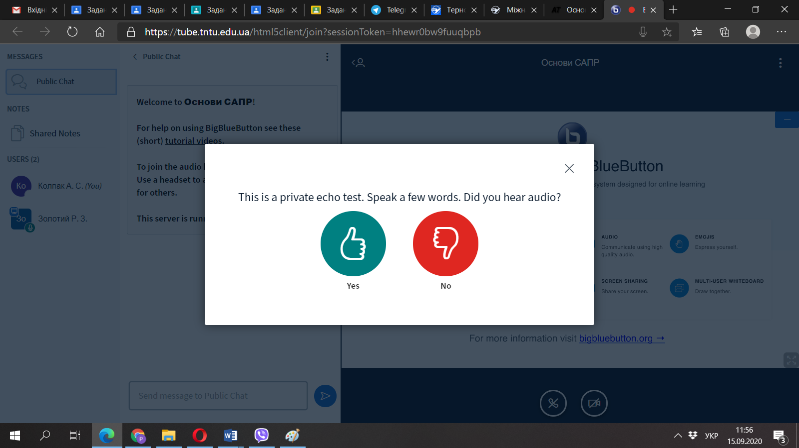
In the next window, turn off the microphone. It should only be turned on if you want to say something.
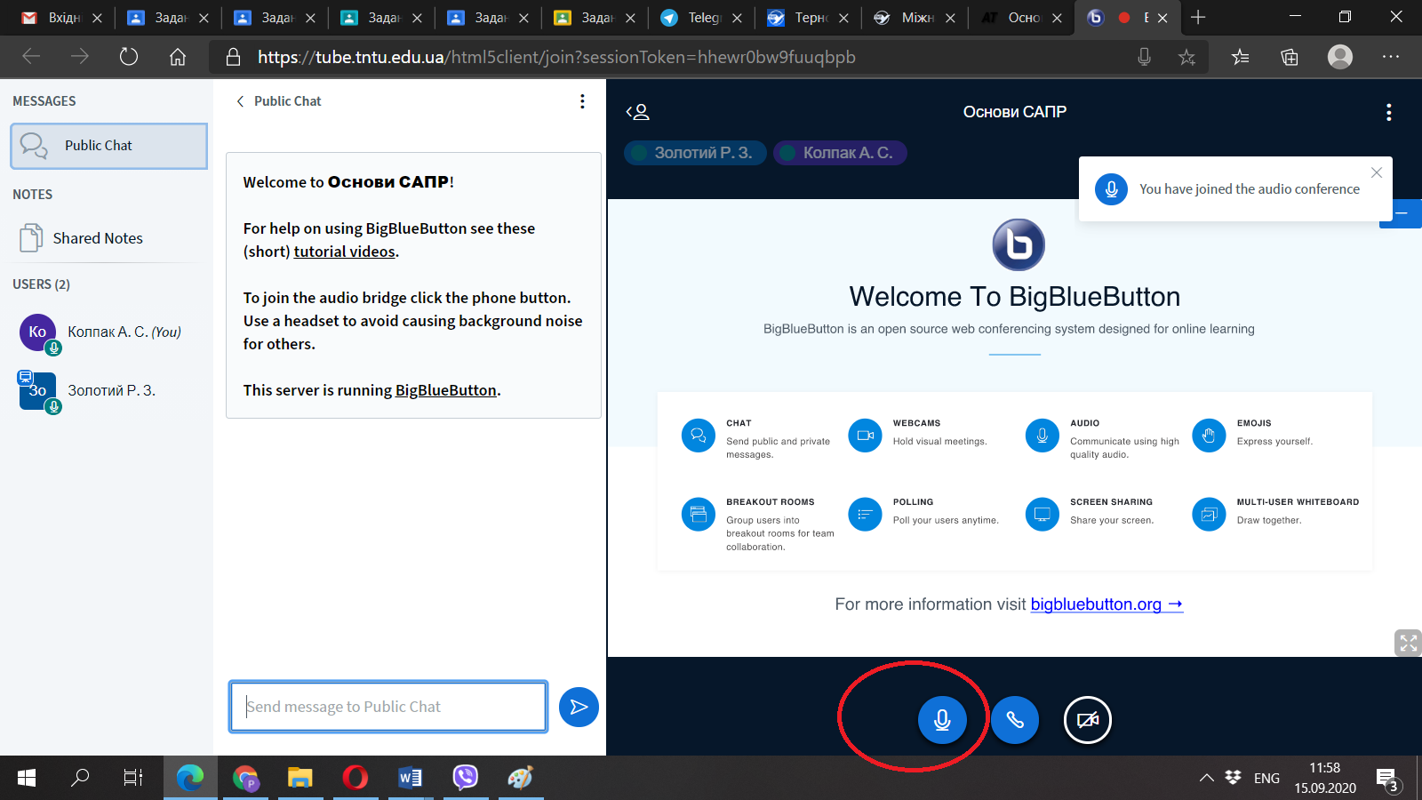

In listener mode, the window areas have the following values:
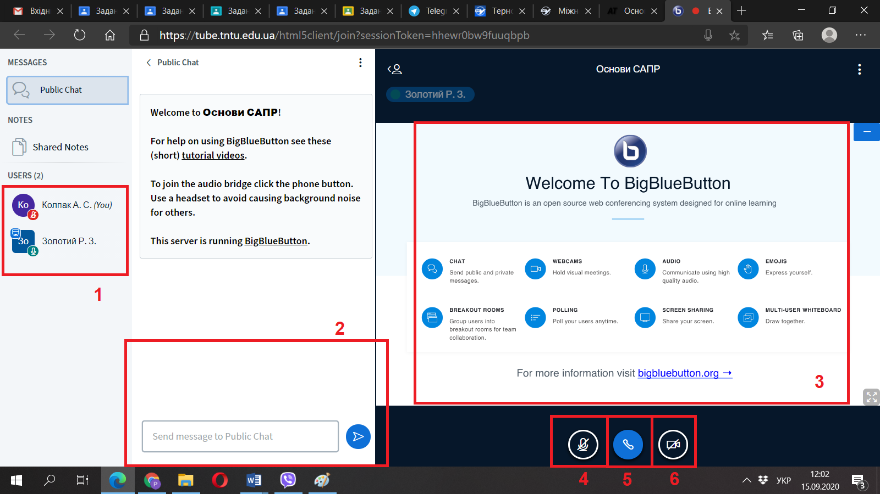
1- List of participants;
2- Public chat (here you can write questions or wishes);
3- Area of presentation;
4- Mute / unmute the microphone;
5- Disconnect from the meeting;
6- Turn the camera on / off.
If you have been granted the right to speak, you will have several additional items:
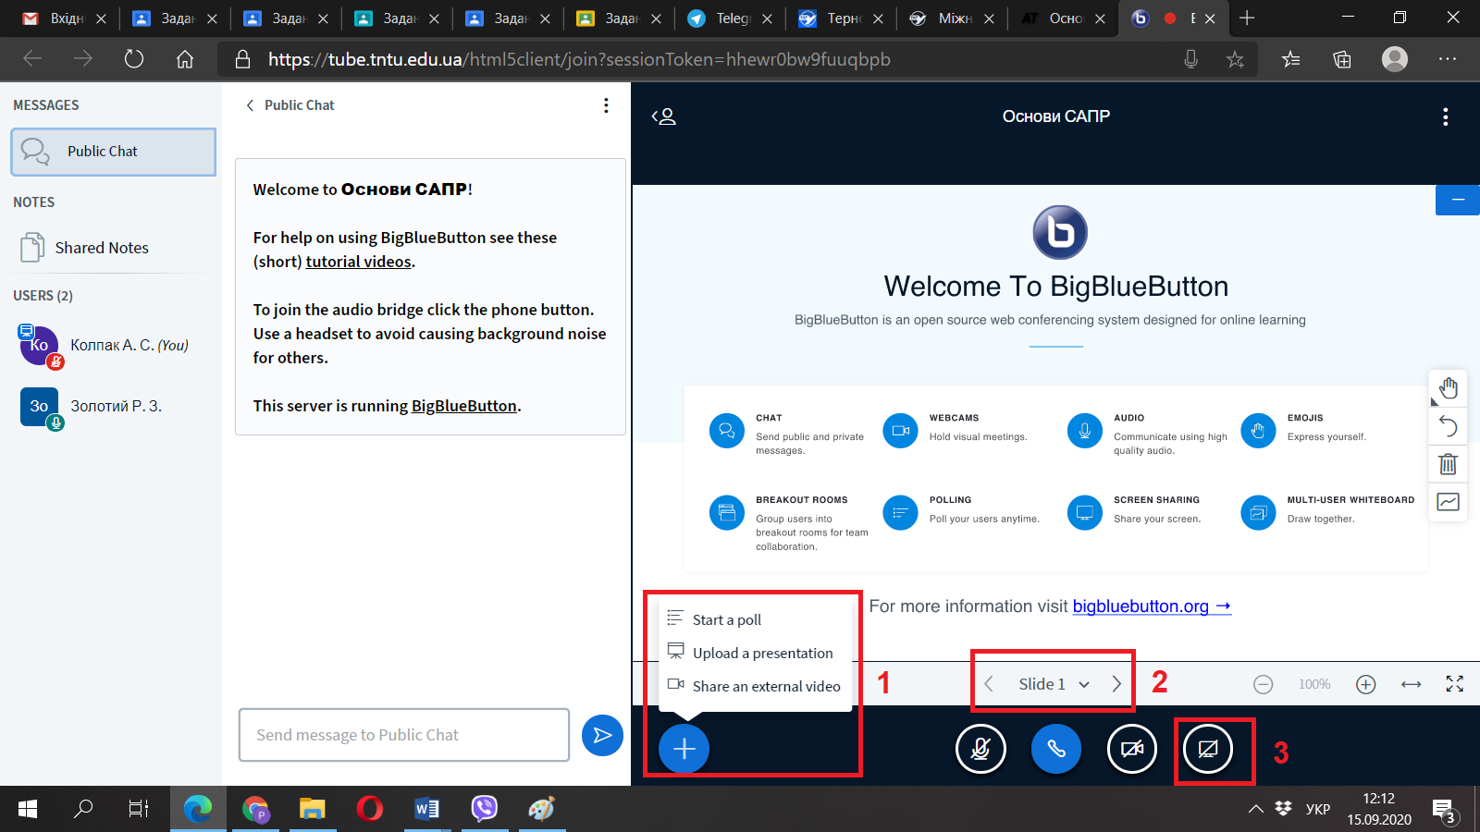
1- button to add a presentation;
2- slide switch button;
3- broadcast button on your desktop.
The window for adding a presentation looks like this:
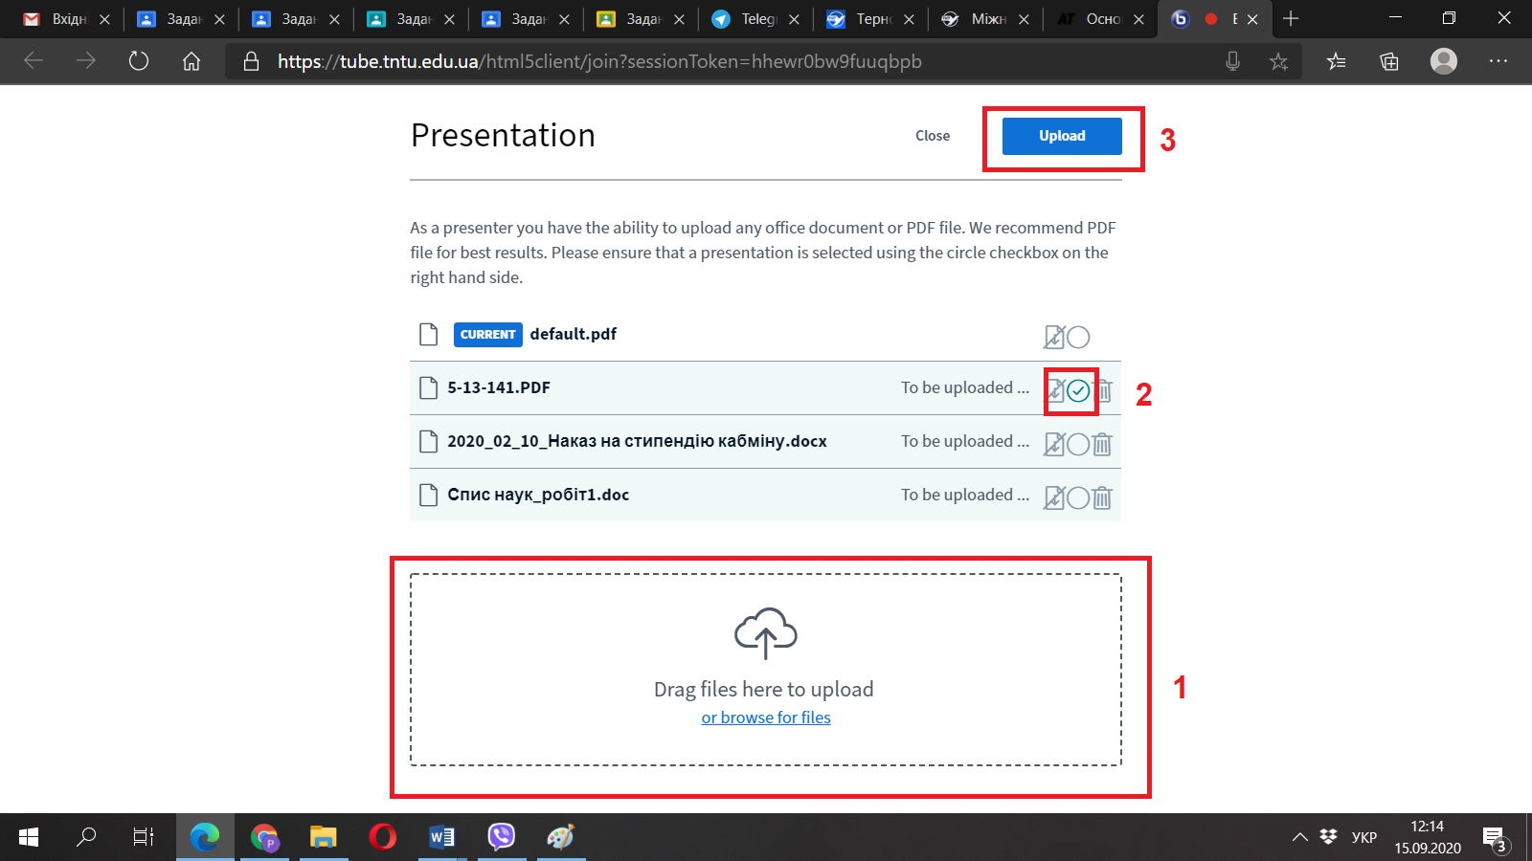
To display your presentation on the screen for all listeners, drag it to field 1, check your document in box 2, and click in box 3.
Your presentation will appear in the window, you can turn on the microphone and start the report.
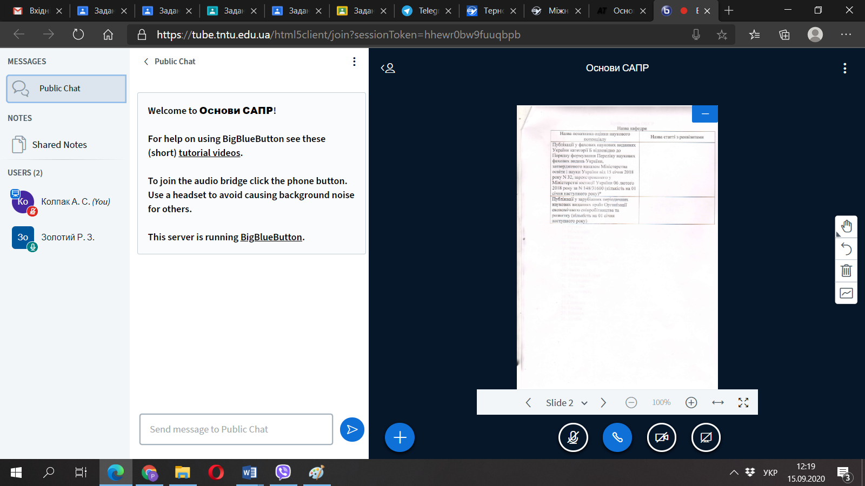
If you have questions, you can ask them by phone:
+380685155028 (Zolotyi Roman)
By mail: icip2020tntu@gmail.com.

